DETECTION of ONLINE SHOPPERS’ PURCHASING INTENTION

Gargee Singh

July 2024

TORONTO METROPOLITAN UNIVERSITY

DECLARATION

I hereby declare that this project report is based on my original work expect for Citations and quotations which have been duly acknowledged.

Name : Gargee Singh

Date : 2024-07-28

ABSTRACT

Shoppers go online first in over 60% of shopping occasions (ThinkwithGoogle 2018, n.d.) and this

constantly flowing stream of clicks holds immensely insightful data about how and at exactly what

point during their web session, do customers decide to make the payment or exit the website or not complete the transaction. Naturally, this has led to companies wanting to harness the power of

all this data, learn from it and make their offerings increasingly more lucrative. The combined power of e-commerce, logistics and social media has always intrigued me, and I chose Clickstream

analytics for this project using the Online Shoppers Purchasing Intention Data Set (UC IrvineMachine Learning Repository, n.d.).

Using this sequential clickstream dataset, my project’s primary focus will be to answer the question

whether machine learning can be used to predict a customer’s intention to make the purchase or not followed by the second question which is a customer’s likelihood to leave the website without

buying a product more commonly known as website abandonment rate. I will try to answer these questions and also try to establish whether or not there is a significant relationship between different pages a customer visits on the website. The combined information from the model should

give us answers that can help predict a website’s purchase conversion as well as abandonment ratio.

The data set I will be using has ten numerical and eight categorical attributes and although there are no null values, it is imbalanced. As initial pre-processing steps I will be working on methods (e.g., Over Sampling, Under Sampling or resampling with different ratios) to balance the data and check for correlation between numerical attributes which would need to be normalized before being used in the model. Once finalized I will proceed to feature selection methods to use only the most relevant features for the models. Once finalized with a balanced ratio between class labels and relevant features the data set will be fed to the different models using the standard train to test ratios.

I propose to start with a classification model using the attribute ‘Revenue’ as the class Label to establish a decision tree of customer’s making the purchase or not. For comparison I also plan to run a random forest model as it is a stronger modeling technique and will help me limit overfitting as well as errors due to any biases in the data which I might overlook in the decision tree. For modeling I plan to use aggregate page views data along with session and user information present in the data. I also plan to explore Support Vector Machine learning models as well as Logistic Regression on my data set so as to have a few good comparisons to make.

In the end I will be using a common matrix to measure the scalability and performance of each model before recommendations about the best model that predicts whether the shopper will make the purchase or is merely scrolling through the shop in their current session.

Link to the Data Set, I downloaded the CSV file from this link – <https://archive.ics.uci.edu/dataset/468>

Table of Contents

INTRODUCTION 6

1.1 General Information 6

RESULTS AND DISCUSSION 18

4.1 Base Model (Logistic Regression) 18

4.1.1 Logistic Regression without normalizing outliers 18

4.1.2 Logistic Regression after normalizing outliers 19

4.1.3 Feature Selection and running all other models with default parameter 20

**LIST OF TABLES**

**LIST OF FIGURES**

**CHAPTER 1**

# **INTRODUCTION**

## **General Information**

Global ecommerce sales reached $5.82 trillion, marking a 10% increase from the previous year. This figure is projected to rise to $6.33 trillion in 2024, representing an 8.8% annual growth rate - the third-highest growth rate in the forecast period from 2021 to 2027 (Shopify 2024). As online sales continue to expand and capture a larger share of the retail market, the ecommerce landscape is becoming increasingly competitive. Companies are intensifying their efforts to attract consumer attention and prevent customers from shifting to competitors. To achieve this, businesses are allocating substantial marketing budgets and focusing on creating personalized online shopping experiences.

Machine learning plays a crucial role in these efforts, with companies utilizing streaming analytics and investing in predictive systems designed to enhance customer engagement. However, these predictive systems do not always achieve high conversion rates, highlighting areas for improvement. One significant challenge is the "rare class problem," which arises from imbalanced datasets and overlapping data issues. This problem, prevalent in machine learning, can reduce the effectiveness of predictive models. The rare class problem occurs when there is a disparity between the majority and minority classes within a dataset . The second problem occurs when the majority and the minority samples overlap in the data space.

## **1.2 Importance of the Project**

This project aims to help online retailers utilize machine learning to boost their conversion rates. The objective is to create a robust machine learning model that continuously learns from shopper data and accurately predicts a customer's likelihood of making a purchase. By implementing this model, companies can enhance their targeted advertising and discount campaigns, thereby attracting more customers to their websites and increasing the likelihood of purchases.

This project also aims to make a significant contribution to the research field by enabling researchers to compare the effectiveness of various over-sampling and under-sampling techniques. By evaluating the performance of different models using these techniques, the project seeks to provide valuable insights into their impact on machine learning outcomes.

## **1.3 Problem Statement**

Using this sequential clickstream dataset, my project’s primary focus will be to answer the question whether machine learning can be used to predict a customer’s intention to make the purchase or not followed by the second question which is a customer’s likelihood to leave the website without buying a product more commonly known as website abandonment rate. I will try to answer these questions and also try to establish whether or not there is a significant relationship between different pages a customer visits on the website. The combined information from the model should give us answers that can help predict a website’s purchase conversion as well as abandonment ratio. Also since the data set is imbalanced , the project aims to deploy various data balancing methods before prediction models.

## **1.4 Scope of the Project**

This project tries to detect online users’ purchasing intention while working with an imbalanced data set. The project focuses on the unbalanced and overlapped data set. In order to balance the data set before recommending a model , the project utilizes

1. RUS as the undersampling technique.
2. Synthetic Minority Oversampling Technique (SMOTE)
3. Borderline – SMOTE
4. SMOTE - ENN

The project also aims to compare the performances of the classifiers with under sampling, oversampling and without any sampling.

* Logistic Regression
* Random Forest
* Decision Tree
* Support Vector Classification
* ADA Boost Classification
* Gradient Boost Classifier
* XGB Classifier

Python is the programming language for this project and a range of libraries and tools, including pandas, NumPy, Matplotlib, Scikit-learn, Imbalanced-learn, smote variants and seaborn have been used for creating these models.

## **1.5 Proposed Solution**

The project will start with a base line model , based off the imbalanced and unscaled data set. Using that as a starting point the project will first employ various other models on imbalanced data set. In order to handle the imbalance and overlap I will utilize random under sampling as well as SMOTE over sampling methods to compare various model performances. Finally the project aims to recommend a model to be deployed for accurately predicting a customers’ online purchasing intention.

CHAPTER 2

Literature Review

One significant analysis is that the number of successful transactions per month is the highest in November.

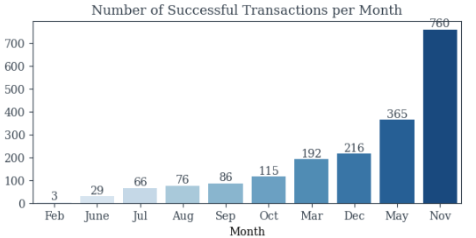

Another point worth noting is that the number of successful transactions surge dramatically on special days.

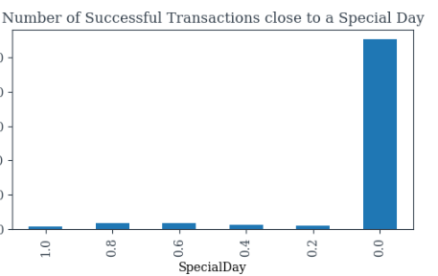

As can be expected customers amongst all the website pages and product related pages have the highest contribution to revenue generation.

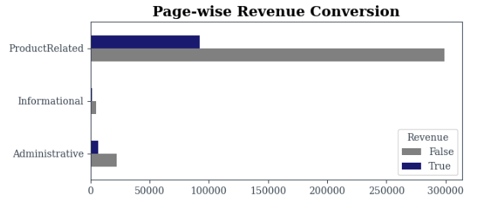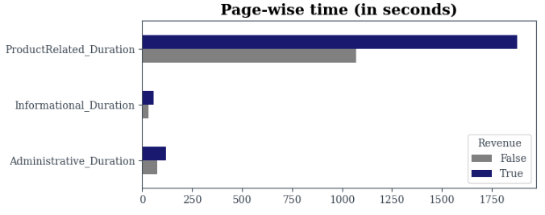

CHAPTER 3

PLAN and METHODOLY

Flow Chart

This will explain in detail exactly how you carried out your data collection, what data you collected and what you hoped it would show. Specifically you should describe how your data will answer your question. You should also highlight any difficulties and problems you had finding the data

**CHAPTER 4**

**ANALYSIS and WORKFLOW**

**3.1 Data Set Features**

Table 1.1 Numerical Features of the Online Purchasing Intention Data Set by Sakar et al.(2019)

|  |  |
| --- | --- |
| Administrative | The number of unique page categories visited by the visitor during the session. |
| Administrative_Duration | Total time duration spent (in sec) on administrative pages |
| Informational | The total number of Informational pages that the user visited |
| Informational_Duration | Total time spend (in sec) on Informational pages |
| ProductRelated | The total number of Product Related pages that the user visited |
| ProductRelated_Duration | Total time spend (in sec) on Product Related pages |
| BounceRates | The percentage of visitors who enter the website through that page and exit without triggering any additional tasks |
| ExitRates | The percentage of pageviews on the website that end at that specific page |
| PageValues | The average value of the page averaged over the value of the target page and/or the completion of an eCommerce transaction.  [More information about how this value is calculated](https://support.google.com/analytics/answer/2695658?hl=en) |
| SpecialDay | The proximity of the site visit to a memorable day |

Table 1.2 Categorical Features of the Online Purchasing Intention Data Set by Sakar et al.(2019)

|  |  |
| --- | --- |
| Month | Month value of the visit date |
| OperatingSystems | Operating system of the visitor |
| Browser | Browser used by the visitor |
| Region | Geographic region from which the visitor initiated the session |
| TrafficType | An integer value representing what type of traffic the user is categorized into. [Read more about traffic types here.](https://www.practicalecommerce.com/Understanding-Traffic-Sources-in-Google-Analytics) |
| VisitorType | Visitor type as ‘‘New Visitor,’’ ‘‘Returning Visitor,’’ and ‘‘Other’’ |
| Weekend | Weekend value signifying whether the visit date is a weekend. |
| Revenue | Class label signifying whether a transaction was completed during the visit. |

**3.2 Data Set Overview**

In this study, I have used the Online Shoppers Purchasing Intention Data Set from Sakar et al.(2018). The data set 12,330 instance and shows each session that belong to a different user in a 1-year period. The target column “Revenue” is a binary column where the values are True or False.

The data set is imbalanced , with only 15.5% (1908) of instances belonging to the minority class and 84.5%(10,422) belong to the majority class. Minority Class here is customer’s who made a purchase while the majority instances are about customers who did not make a purchase.

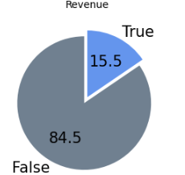

The data set does not have any NULL values though there are few (125) duplicate records. .Due to the small volume and nature of the data as each line represent a user who accessed the website. It is possible that two users had a similar behaviors, we will not be removing duplicates and keep them in our data set.

The numerical columns have some outliers , but since most of these outliers belong to sessions where the clients made a purchase (minority class label) I will not be removing these outliers and try to minimize their impact with standardization.

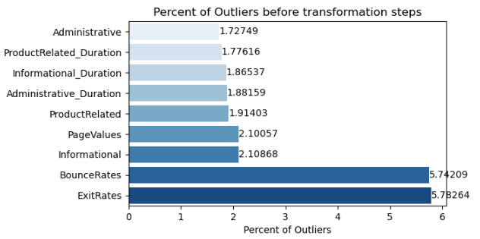

There are 18 attributes in the data consisting of 10 numerical and 8 categorical attributes.

**3.3 Workflow**

**3.3.1 Preprocessing Steps**

Since the data does not contain any NULL values data cleaning is not required however there are a few issues to overcome.

1. First one being some outliers in numerical columns , these will be normalized with the help of BOXCOX transformation. The Box-Cox transformation is a family of power transformations designed to stabilize variance and make the data more closely approximate a normal distribution.
2. The second being the existence of nominal features where some of these have an integer data type. In order to avoid these features impacting the model as a numerical , the columns – ( Month, Visitor Type Browser, Operating Systems and Traffic Type) been transformed into an indicator variable with the help of one hot encoding / label encoding. The two Boolean columns (Weekend and Revenue) were converted to integers.
3. To address the potential impact of feature scale on model performance, the Min-Max Scaler was employed. This technique transforms all features in the dataset to a uniform range, typically [0, 1]. By normalizing features within this specified range, the Min-Max Scaler helps to minimize bias that could arise from differences in feature scales, ensuring that no single feature disproportionately influences the model. This preprocessing step promotes a more balanced and effective model training process.
4. Feature Selection :

**3.3.2 Train Test Split**

The data set was split into training set and Test for various experiments to be run and compared. Splitting the data ensures that size of the majority and minority classes were same for every experiment. I have used a 80:20 train : test ratio , hence training the models on 80% of the data while testing it on 20% of the data set.

**3.3.3 Sampling Methods**

< > Categories of experiments were carried out on the data set. To establish a base performance I have a run a base model on the data without normalizing the outliers followed by running the model once again after normalizing the outliers. Observing some improvement in the model , I have continued to use the data with normalized outliers and further scaled it before feature selection and running the various models.

CHAPTER 4

# **RESULTS AND DISCUSSION**

## **4.1 Base Model (Logistic Regression)**

### **4.1.1 Logistic Regression without normalizing outliers**

*(Notes : Ro indicates Majority recall, R1 indicates Minority recall)*

The first experiment is run on the data set without normalizing the outliers (one hot encoding and min max scaler were applied) as to keep that as a base line for all models.

This first base model runs with 0.86 accuracy which is decent start but we have to keep in mind that the data set is imbalanced so accuracy will not be an ideal measure. The imbalance is clearly reflected by the recall values, recall of the majority class (R0)is at 0.98 while the minority class (R1)is only at 0.24 which demonstrates that the classifier has a strong bias towards the Do Not Buy category .I have also looked at the F2 since for our model we would want to minimize false negatives but the F2 score is considerably lower than the F1 score which tell us that there is room to improve false negatives.

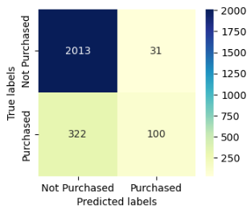

|  |  |  |  |  |  |  |  |  |  |
| --- | --- | --- | --- | --- | --- | --- | --- | --- | --- |
|  | Misclassifications | Accuracy | Precision | R1 | R0 | F1 Score | F2 Score | Type I errors | Type II errors |
| Logistic Regression | 353 | 0.86 | 0.76 | 0.24 | 0.98 | 0.36 | 0.28 | 31 | 322 |

Next we compare the training and the test data set scores for this made model. The accuracy is on training is higher as would be expected but the lower precision on training score , indicates a possibility that we have a bad ratio of negative to positive in the test set , once again potentially caused due to the imbalanced data set. The difference in training and test accuracy is not high enough to suggest the model is overfitting.

|  |  |  |  |  |
| --- | --- | --- | --- | --- |
| Data Set | Accuracy | Precision | Recall | F1 Score |
| Training Data | 0.89 | 0.74 | 0.37 | 0.50 |
| Test Data | 0.87 | 0.75 | 0.36 | 0.49 |

As our performance measures have indicated the imbalance in the data set is affecting performance of the models so we will be deploying balancing techniques , I will be using SMOTE Oversampling (Standard and Border Line) and Random Under sampling to balance the data set.

### **4.1.2 Logistic Regression after normalizing outliers**

As a next step we will perform the same experiment but this time after normalizing the outliers in order to see if it has any impact on model performance. The data set at this stage does not have the same ratio of outliers , the BOXCOX transformation has also reduced the correlation. One hot encoding and MinMax Scaler have also been applied as the base model.

We clearly see the impact of normalization on outliers ,accuracy of the model has slightly improved and Recall for the minority class and F2 score both have shown considerable improvement, which shows that despite the imbalance removing outliers has also improved model performance. On the flip side we see that though overall misclassification has gone down , false positive values have gone up ,we will monitor how this changes with other models however keep our focus on reducing the False Negatives.

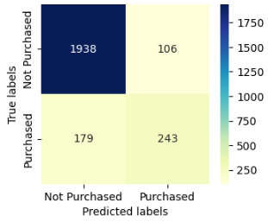

|  |  |  |  |  |  |  |  |  |  |
| --- | --- | --- | --- | --- | --- | --- | --- | --- | --- |
|  | Misclassifications | Accuracy | Precision | R1 | R0 | F1 Score | F2 Score | Type I errors | Type II errors |
| Logistic Regression | 285 | 0.88 | 0.7 | 0.58 | 0.95 | 0.63 | 0.6 | 106 | 179 |

Since we have seen positive impact of removing outliers on our base model, we will proceed with this data and apply other models on the data to compare performance.

### **4.1.3 Feature Selection and running all other models with default parameter**

Starting with 10 numerical and 8 categorical features , the data set ends up with 66 features (after one hot / label encoding). Before proceeding with modelling , feature selection was performed at this stage and the data set ends up with a count of **51 significant features**.

After feature selection , a total of 8 experiments were performed on the data set at this stage and their performance was compared with repeated stratified cross validation across 7 splits , repeating the process 3 times.

At this stage ,with imbalanced data set and having run these models at default , Random Forest Classification and Gradient Boost Classifier seem to return the best results followed by XGB Classifier. Gaussian Naiye Bayes seems to be the worst performing model with only 19% accuracy and despite the data being imbalanced towards the **“did not purchase”** class, the model is predicting 98% of instances as a **“purchased”** which is incorrect.

**Cross Validation Scores :**

|  |  |  |  |  |  |
| --- | --- | --- | --- | --- | --- |
| **Metric** | **Accuracy** | **Precision** | **Recall** | **AUC** | **F1** |
| Logistic Regression | 90% | 69% | 60% | 91% | 90% |
| Random Forest Classifier | 91% | 75% | 54% | 92% | 91% |
| Decision Tree Classifier | 86% | 55% | 57% | 74% | 86% |
| Gaussian NB | 19% | 16% | 98% | 69% | 19% |
| Support Vector Classification | 90% | 70% | 63% | 91% | 90% |
| Ada Boost Classifier | 89% | 67% | 56% | 91% | 89% |
| Gradient Boosting Classifier | 91% | 72% | 60% | 93% | 91% |
| XGB Classifier | 90% | 70% | 58% | 92% | 90% |

**Base Model Evaluation**

* 1. Misclassifications

Naiye Bayes Classification has the highest number of misclassifications because unlike other models it is also misclassifying the majority class and predicting them as belonging to the majority class.

* 1. Majority and Minority Recall for each model

As expected due to the imbalance all models (except Naiye Bayes) show a very high majority recall and a weak minority recall.

Table with model scores:

|  |  |  |  |  |  |  |  |  |  |
| --- | --- | --- | --- | --- | --- | --- | --- | --- | --- |
| **Description** | **Misclassifications** | **Accuracy** | **Precision** | **Recall Minority** | **Recall Majority** | **Type I errors** | **Type II errors** | **F1 Score** | **F2 Score** |
| Logistic Regression | 282 | 0.89 | 0.7 | 0.58 | 0.95 | 105 | 177 | 0.63 | 0.6 |
| Random Forest Classifier | 267 | 0.89 | 0.76 | 0.53 | 0.97 | 70 | 197 | 0.63 | 0.56 |
| Naiye Bayes Classifier | 1948 | 0.21 | 0.18 | 0.99 | 0.05 | 1945 | 3 | 0.3 | 0.52 |
| Decision Tree Classifier | 350 | 0.86 | 0.59 | 0.54 | 0.92 | 157 | 193 | 0.57 | 0.55 |
| Support Vector Classifier | 264 | 0.89 | 0.72 | 0.62 | 0.95 | 102 | 162 | 0.66 | 0.64 |
| ADA Boost Classifier | 283 | 0.89 | 0.7 | 0.58 | 0.95 | 106 | 177 | 0.63 | 0.6 |
| Gradient Boost Classifier | 269 | 0.89 | 0.72 | 0.59 | 0.95 | 95 | 174 | 0.65 | 0.61 |
| XG Boost Classifier | 290 | 0.88 | 0.69 | 0.56 | 0.95 | 105 | 185 | 0.62 | 0.58 |

**4.1.4 Under Sampling Results**

Comparing the best R1 and F2 scores for each model after random under sampling the scores before sampling.

Chart 12.1 Best Recall after under sampling and before sampling

Chart 12.1 Best F2 after under sampling and before sampling

Most models show a significant improvement in the recall as well as the F2 score after random under sampling which shows the balancing the data has improved the model performance. Random Forest classifiers has shown the highest gain in the recall value followed by XGBoost Classifier.

Comparing each model’s cross validation score at different under sampling levels (0.2 to 1) .Since imbalanced models often lead to high accuracy as the model mis classifies most instances to the majority class it is understandable that accuracy begins to drop with the increase in under sampling ratio and as the data reaches an equal balance the accuracy is down by almost 6% for all models.

|  |  |  |  |  |  |  |  |  |
| --- | --- | --- | --- | --- | --- | --- | --- | --- |
|  | **Unsampled** | **Random Under sampling Levels** | | | | | |  |
|  | **Accuracy** | **0.2** | **0.4** | **0.5** | **0.6** | **0.8** | **1** | **Difference** |
| LogisticRegression | 90% | 89% | 87% | 86% | 86% | 85% | 84% | 6% |
| RandomForestClassifier | 91% | 90% | 87% | 87% | 86% | 86% | 85% | 6% |
| DecisionTreeClassifier | 86% | 86% | 82% | 81% | 80% | 80% | 79% | 7% |
| SVC | 90% | 90% | 87% | 86% | 85% | 85% | 84% | 6% |
| AdaBoostClassifier | 89% | 88% | 85% | 85% | 84% | 84% | 83% | 6% |
| GradientBoostingClassifier | 91% | 90% | 87% | 87% | 87% | 86% | 85% | 6% |
| XGBClassifier | 90% | 89% | 86% | 85% | 85% | 85% | 84% | 6% |

Recall on the other hand shows considerable improvement with increase in under sampling ratio and the best recall being at under sample ratio of 1.

|  |  |  |  |  |  |  |  |  |
| --- | --- | --- | --- | --- | --- | --- | --- | --- |
|  | **Recall** | **0.2** | **0.4** | **0.5** | **0.6** | **0.8** | **1** | **Difference** |
| LogisticRegression | 60% | 62% | 76% | 78% | 79% | 81% | 82% | 22% |
| RandomForestClassifier | 54% | 58% | 74% | 78% | 80% | 83% | 85% | 31% |
| DecisionTreeClassifier | 57% | 59% | 68% | 71% | 74% | 77% | 79% | 22% |
| SVC | 63% | 66% | 79% | 80% | 80% | 81% | 81% | 18% |
| AdaBoostClassifier | 56% | 58% | 69% | 73% | 75% | 79% | 81% | 25% |
| GradientBoostingClassifier | 60% | 63% | 75% | 78% | 81% | 83% | 84% | 24% |
| XGBClassifier | 58% | 61% | 73% | 76% | 79% | 83% | 84% | 26% |

F2 scores exhibit a similar patter as the recall score .

|  |  |  |  |  |  |  |  |  |
| --- | --- | --- | --- | --- | --- | --- | --- | --- |
|  | **F2 Score** | 0.2 | 0.4 | 0.5 | 0.6 | 0.8 | 1 | Difference |
| LogisticRegression | 62% | 63% | 76% | 78% | 80% | 82% | 83% | 21% |
| RandomForestClassifier | 57% | 61% | 75% | 79% | 81% | 83% | 85% | 28% |
| DecisionTreeClassifier | 57% | 59% | 68% | 71% | 74% | 77% | 79% | 23% |
| SVC | 64% | 67% | 78% | 80% | 80% | 82% | 82% | 18% |
| AdaBoostClassifier | 58% | 60% | 71% | 74% | 76% | 80% | 82% | 24% |
| GradientBoostingClassifier | 62% | 65% | 76% | 79% | 81% | 83% | 84% | 22% |
| XGBClassifier | 60% | 63% | 74% | 77% | 79% | 83% | 84% | 24% |

Comparing the models above Random Forest Classifier is the best performing model which has shown considerable improvement in recall score while a similar drop in accuracy. Another approach possible would be try various under sampling levels which result in the best performance score while balancing the trade- off between accuracy and recall.

**4.1.5 Over Sampling Results**

**4.1.6 Conclusion & Hyperparameter Tuning**

After conducting 2,011 experiments using hybrid sampling with nine undersampling and ten oversampling ratios, the project has achieved its objectives.

Overall, hybrid sampling has significantly increased the purchase intention detection rate. The best hybrid sampling technique is Random Undersampling (80%) and Standard SMOTE (80%) with Random Forest, yielding a Recall of 0.8521 for the majority class and 0.8564 for the minority class.

Random Forest functions well with all hybrid sampling techniques compared to the other classifiers,. Random Forest with the hybrid sampling technique Random Undersampling + Standard SMOTE produces the finest results.

5.2 Recommendations

Applying feature selection to future projects could increase accuracy and clarity while decreasing computational complexity. According to a study by Singh and Jain (2019), the true positive rate (TPR) can be substantially increased by employing feature selection techniques such as filter and wrapper. In the paper, except for the Random Forest classifier, applying a filter or wrapper enhances the TPR of J48, AdaBoost, Naive Bayes, and PART classifiers. Another suggestion would be to include algorithm fairness within the project's scope. Since this project demonstrates that certain classifiers are susceptible to bias towards a particular class, addressing algorithm fairness would aid in illuminating the factors influencing the detection rate. Hasanin and Khoshgoftaar (2018) stated that RUS often leads to losing important information as it randomly eliminates patterns of the majority class. Consequently, additional undersampling techniques can be incorporated into the experiments by exploring more undersampler options available in the research field. Koziarski (2021) proposed an undersampling technique, Synthetic Majority Undersampling Technique (SMUTE), which has proven a viable alternative to RUS.

Citations -

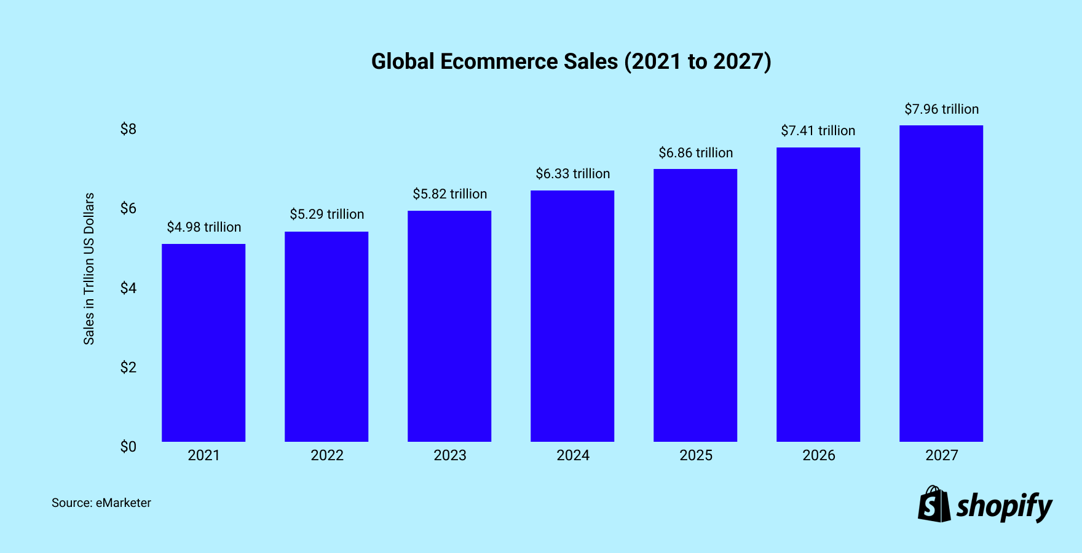

<https://www.shopify.com/ca/blog/global-ecommerce-sales>